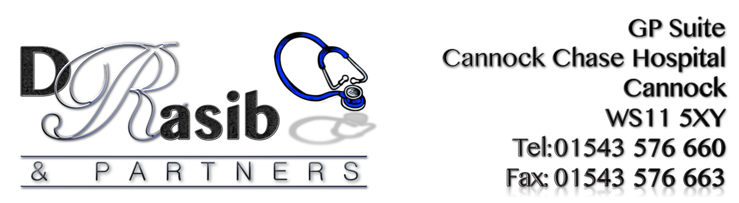

P.P.G. MEETING

Date: Wednesday 13th December 2018
@ 12.00pm
Location: GP Suite Cannock Chase Hospital.

Minutes

1) Persons Present: | Sam Rasib, David Stagg, Margaret Price, Janice Lloyd, Pam Burlingham, Sarah Giles, Val Cox.
2) Apologies: | Patrick Pincombe, Geoff Hackett, Lilian Hyde, Sue Andrews, Charles McCrone, Betty Chapman.
3) Minutes of previous meeting held 4th October 2017: | Minutes of meeting agreed as correct and passed.
4) Managers Report: | Postponed over to next meeting.
5) Chairman, group items: | Weekly Walk Progress. It was noted that walks continuing, but need to spread the word and find more participants.  Request made for help from anyone interested in helping to format a collating form. It was agreed to meet 24th January 11o/c to format the form, and 21st February to collate the completed forms. Approximately 2hrs each.
 | Sam explained the SESCCG are interested in improving Out Of Hours services and welcome any suggestions at http://www.elesurvey.co.uk
6) Any other business: | Margaret asked if a) The practice had been approached to go in with New Cross. Sam said it was something that was in discussion at the time when Dr Rasib first took over but nothing has progressed from it. Sam explained that the practice were in progress of settling a lease with New Cross and will stay where at the GP Suite for the next few years.  b) Sam said that patient records are not being taken over by a private company. C) Sam said that they had not been approached regarding New Cross taking over all phlebotomy services for the Cannock area.

Date of Next Meeting:

14th March 2018 @ 3p.m.

